1.Create Tamplate Configuration.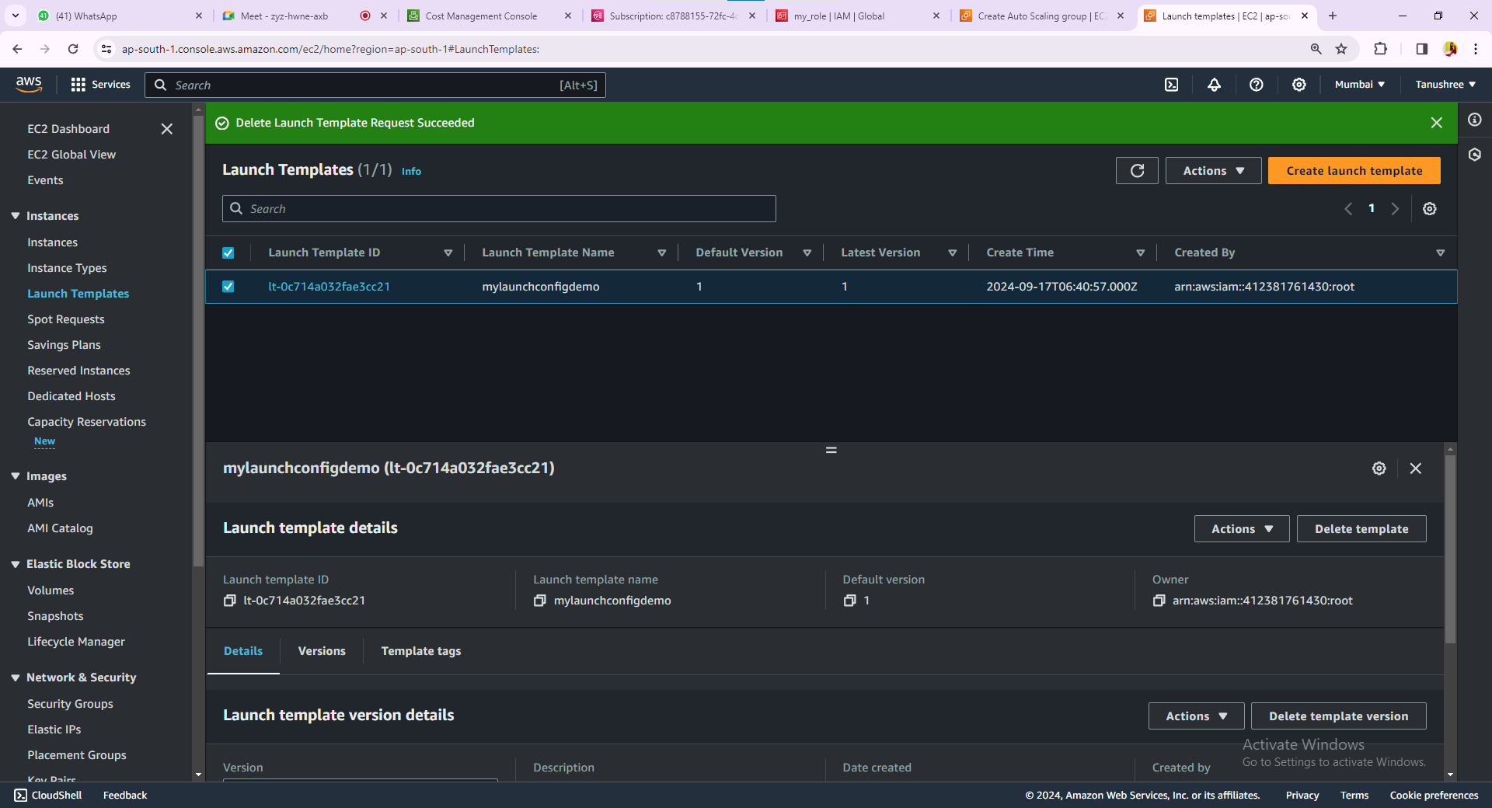2.Select the Availability zone.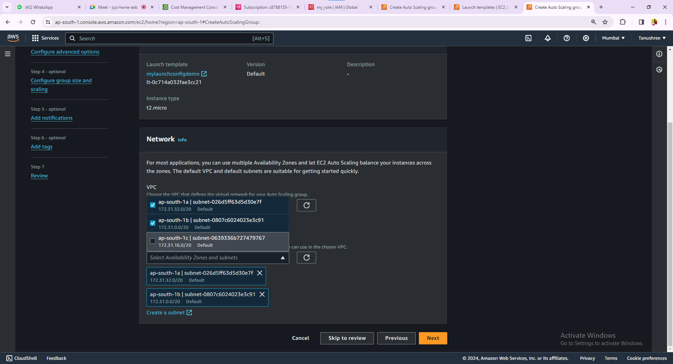

3.Group size and scaling(as per requirement).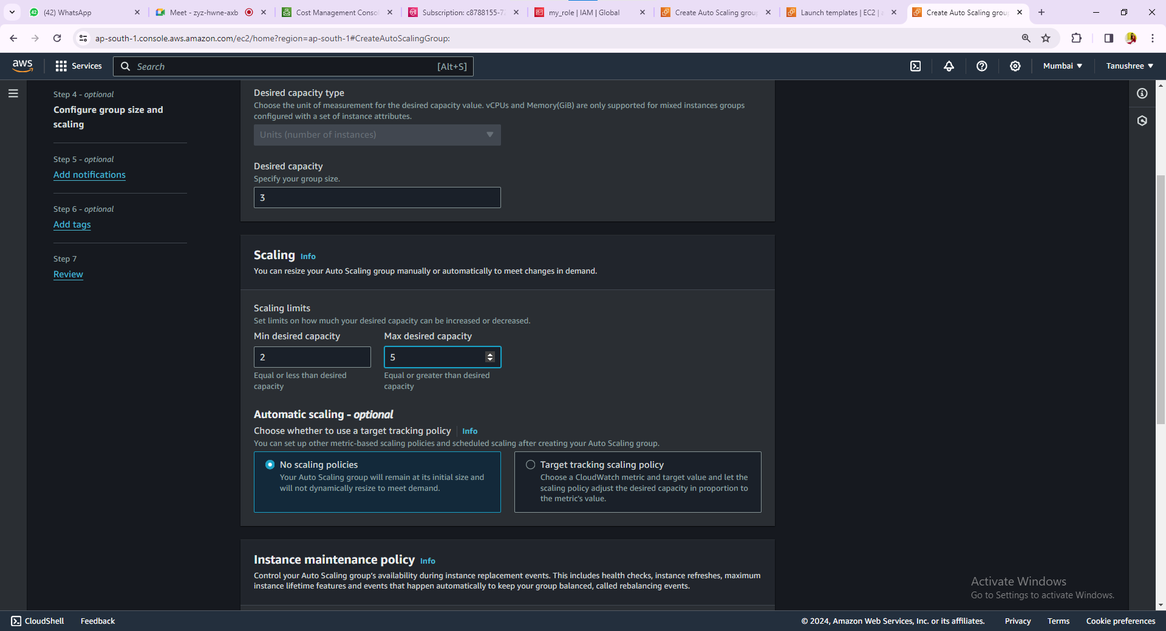4.Add Notification.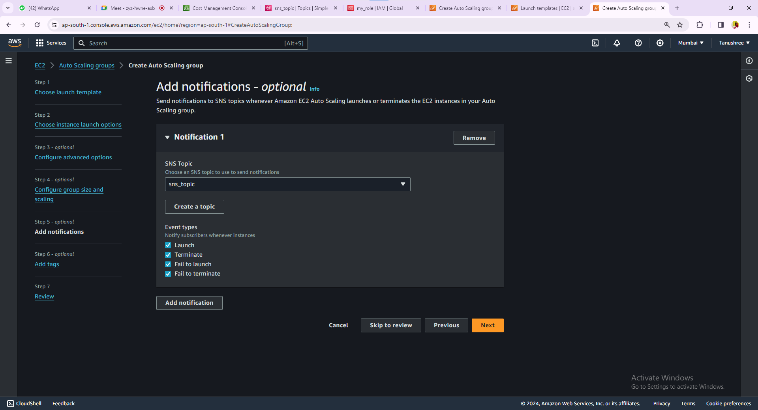

5.Auto Scaling is been created.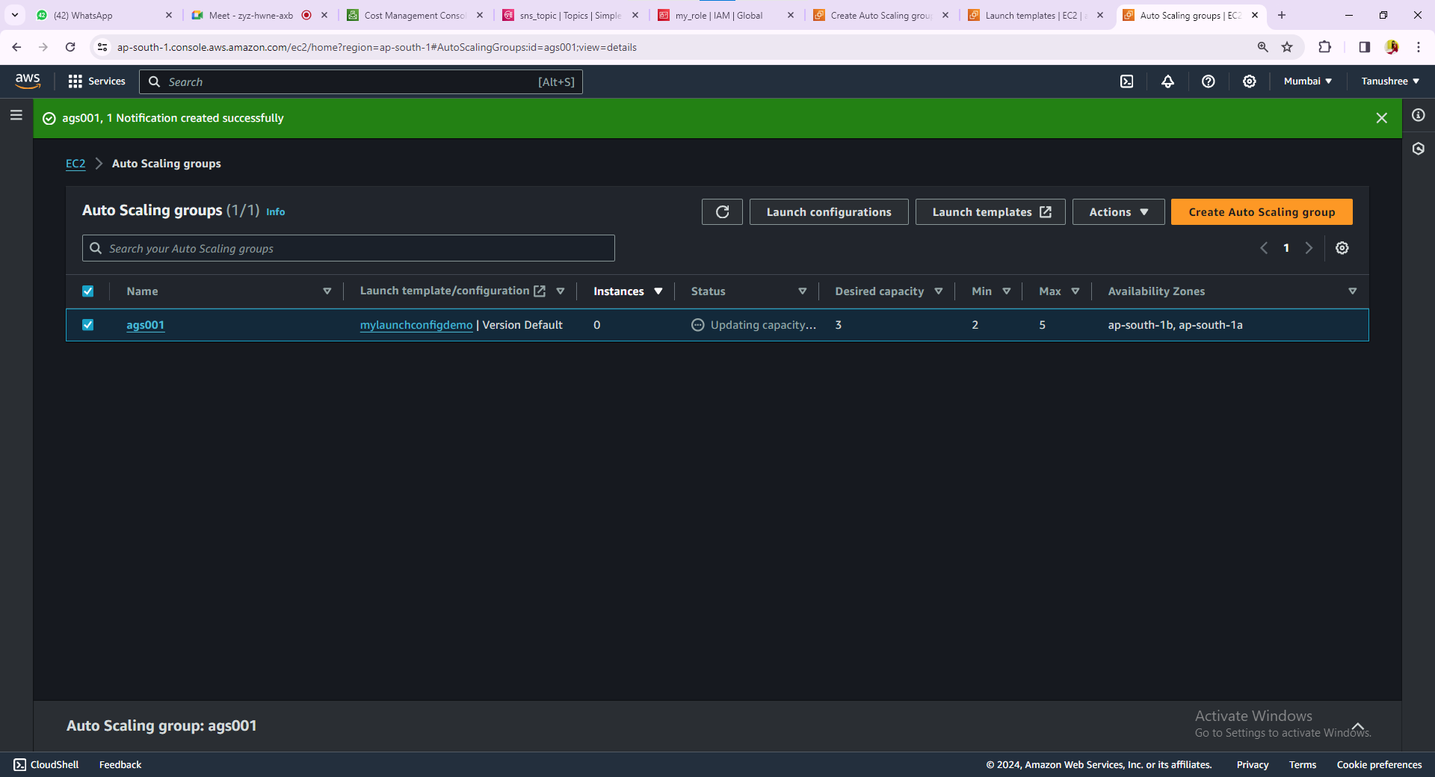6.Auto scaling has created 3 Instances as per we require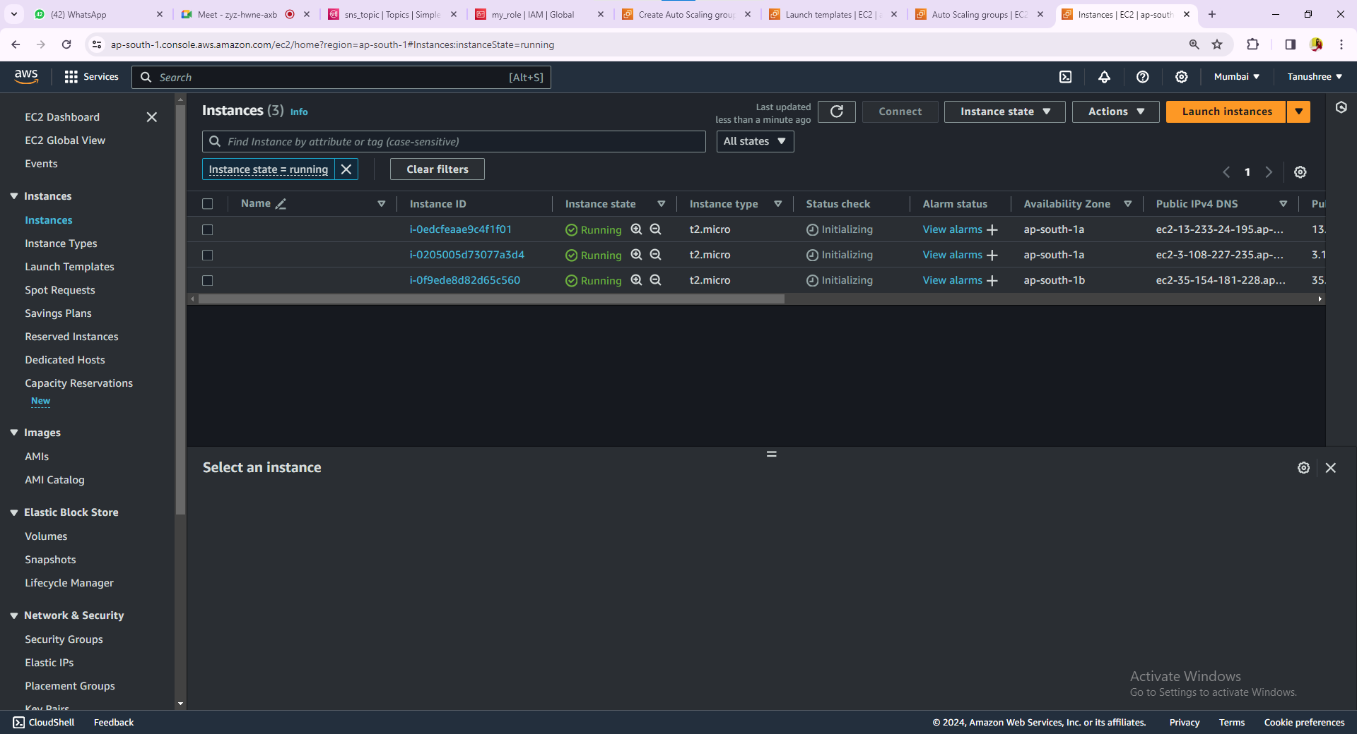

7.Manually we are changing the value of Desired capacity from 3 to 2. It will remove 1 Instance from the 3 Instance.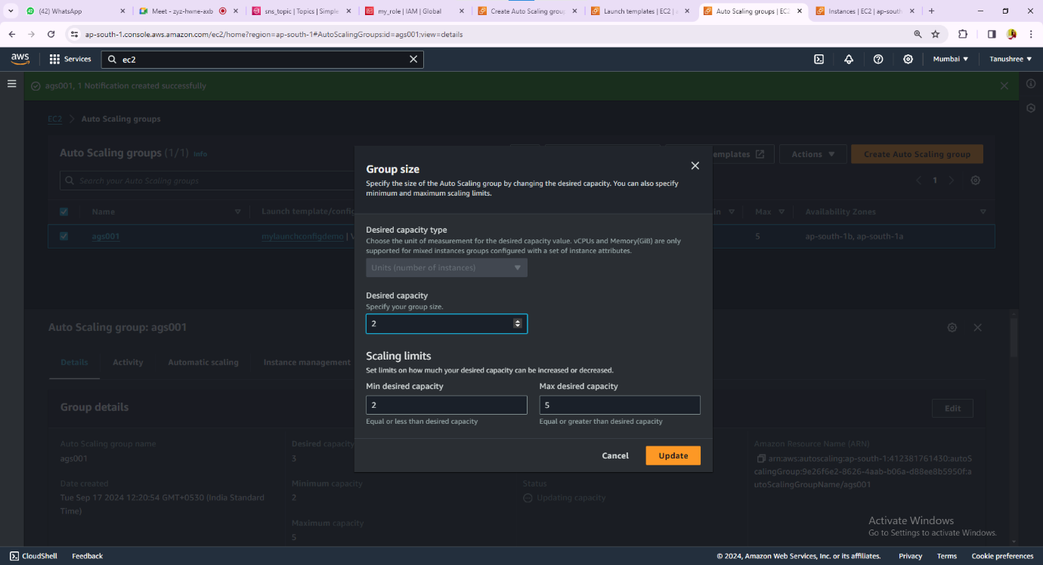8.The Instance has been removed.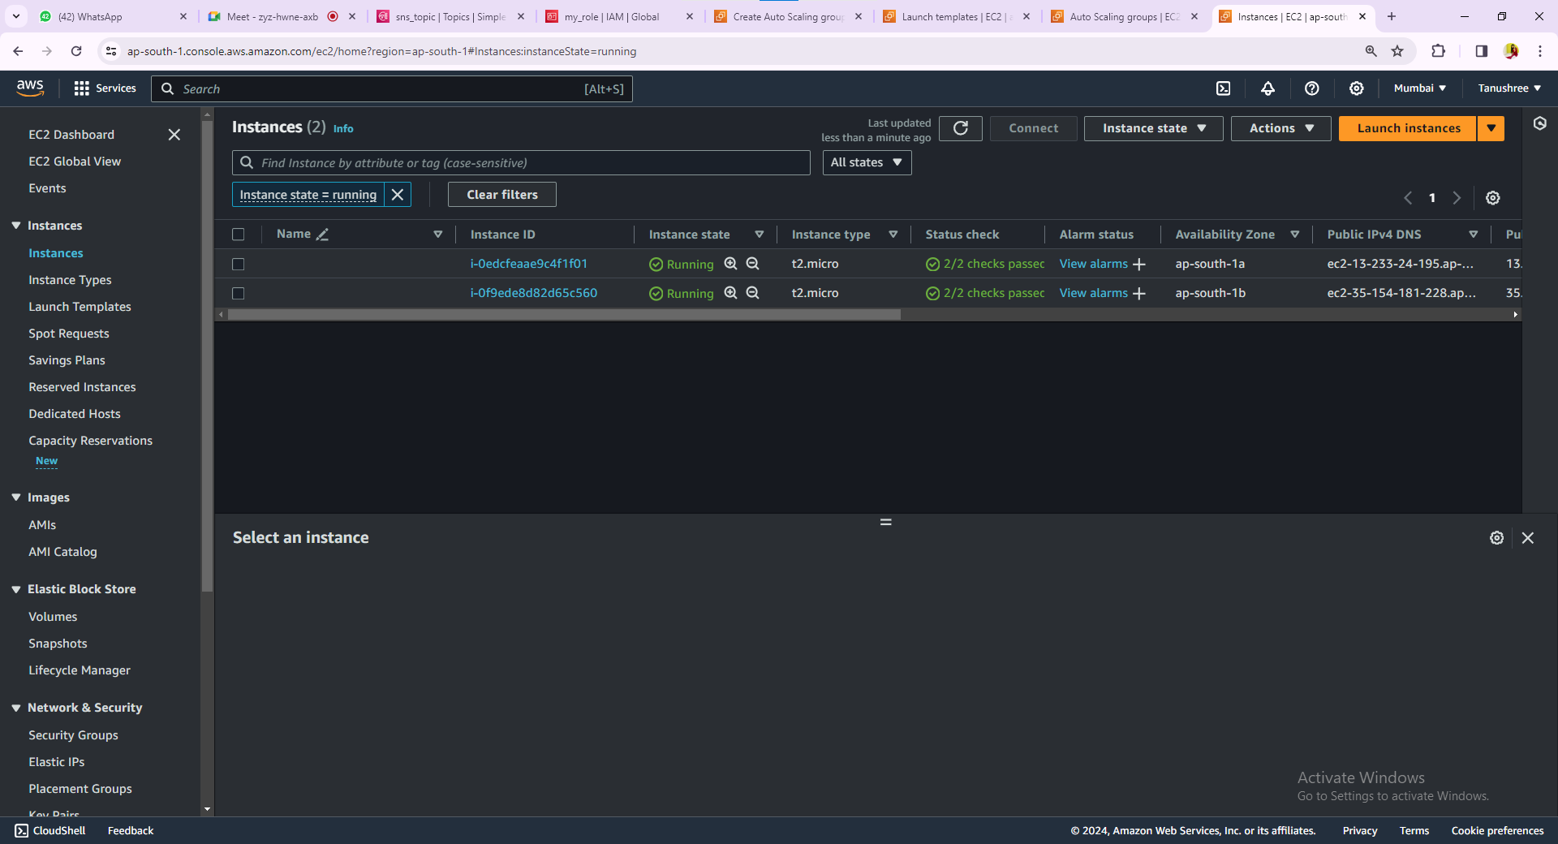

9.Now Create Alarm for auto scaling select the time period abd change it into 120 second that is 2 min as shown below.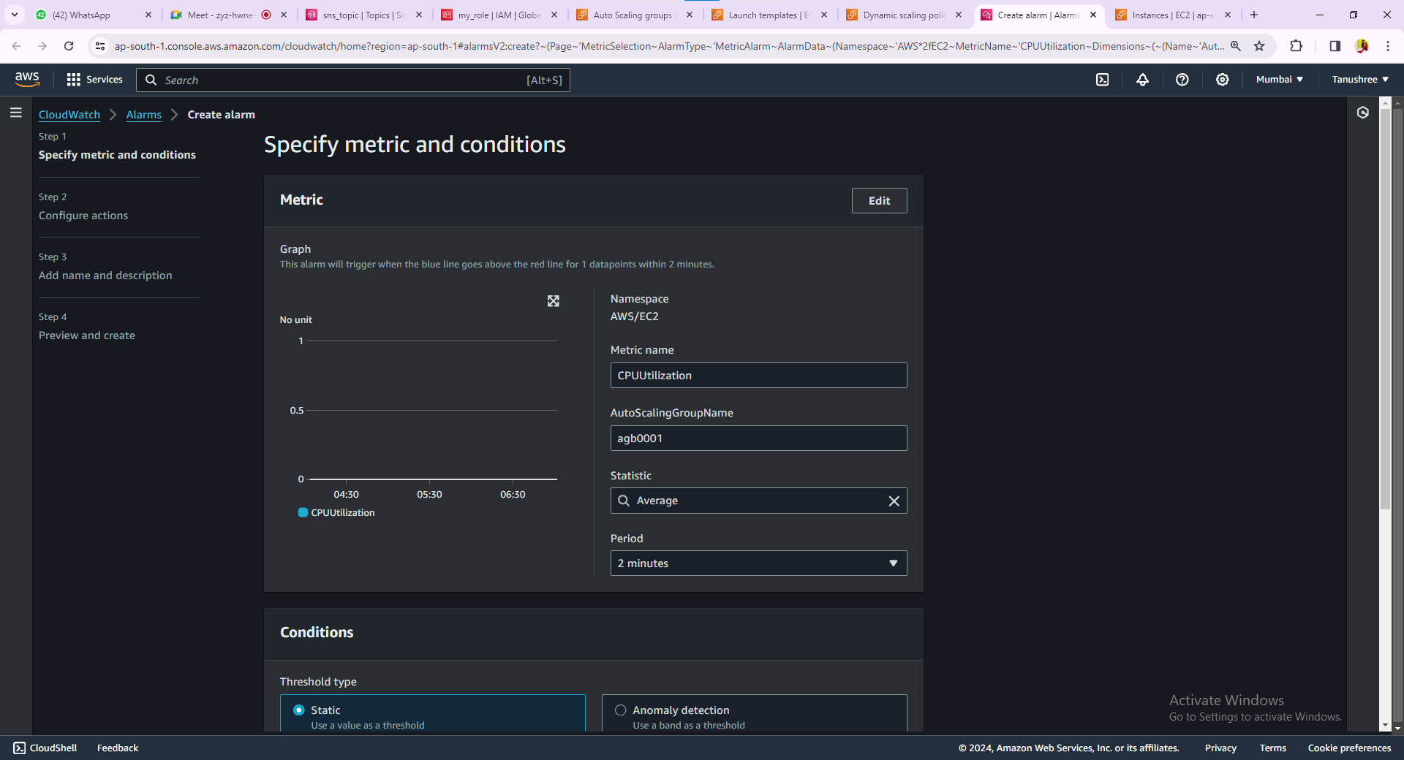10.Now the Alarm has been created.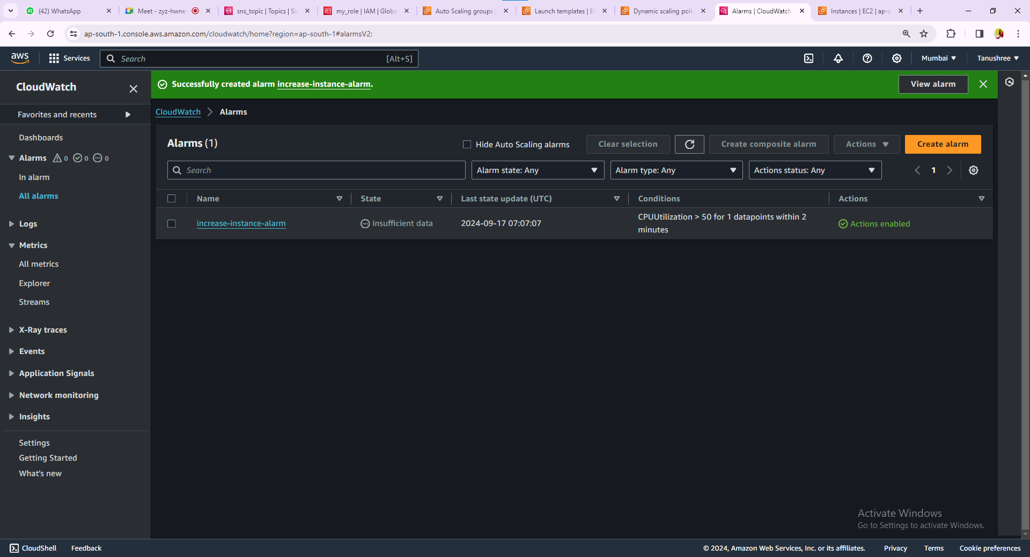

11.Create Dynamic Scaling.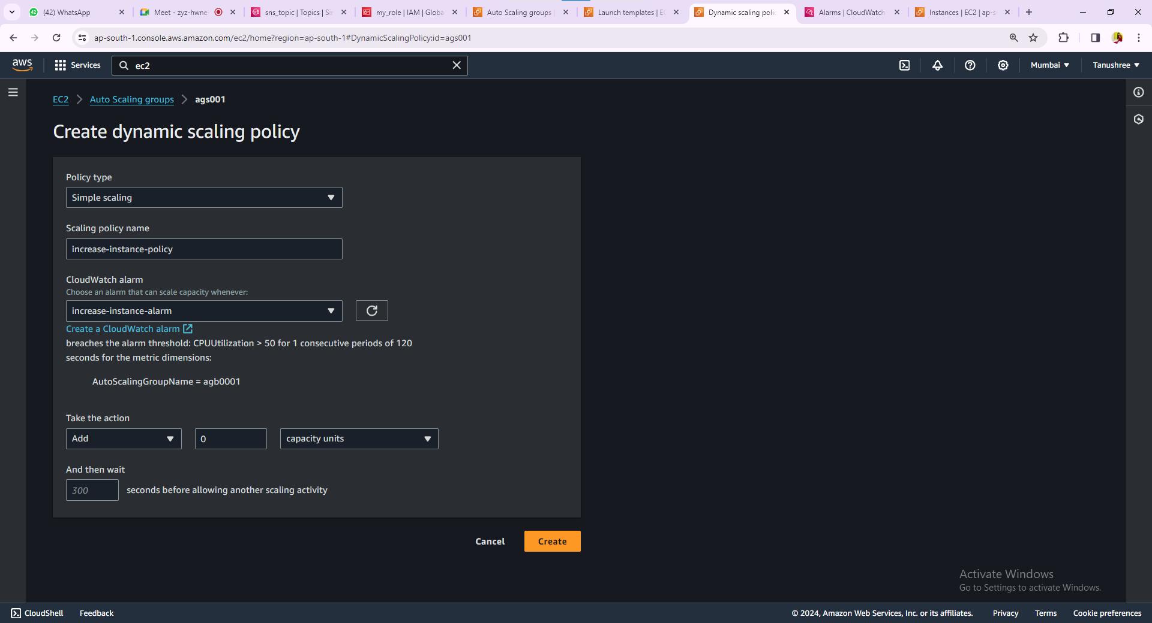12.The Instance Policy has been increased.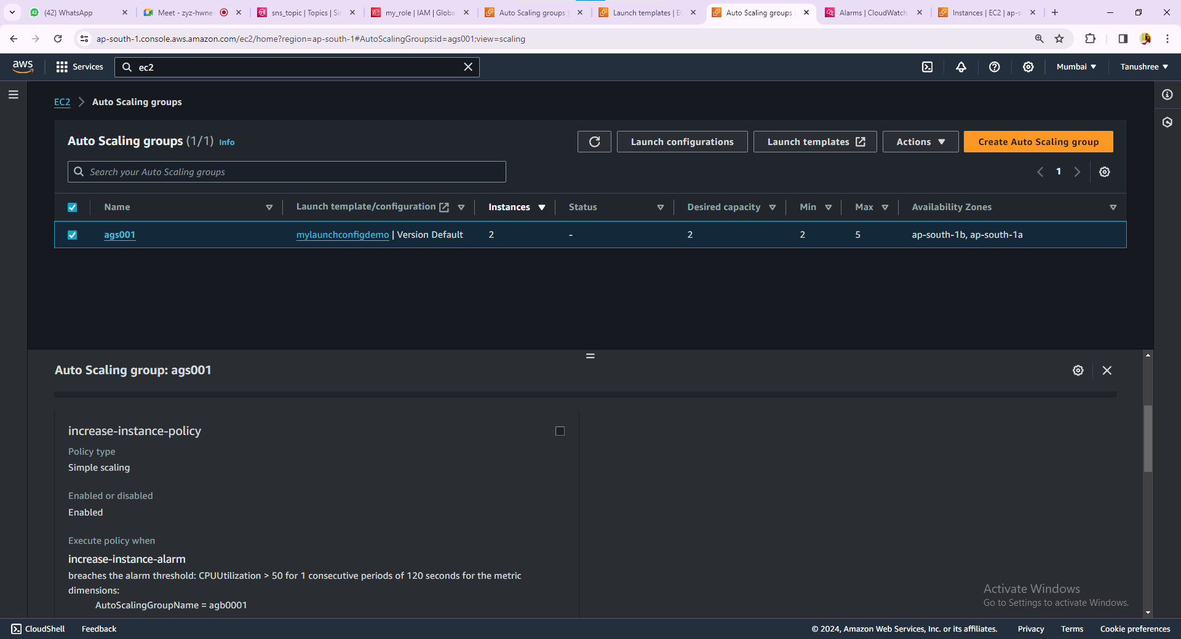

13.Now we have to Decrease the instance policy.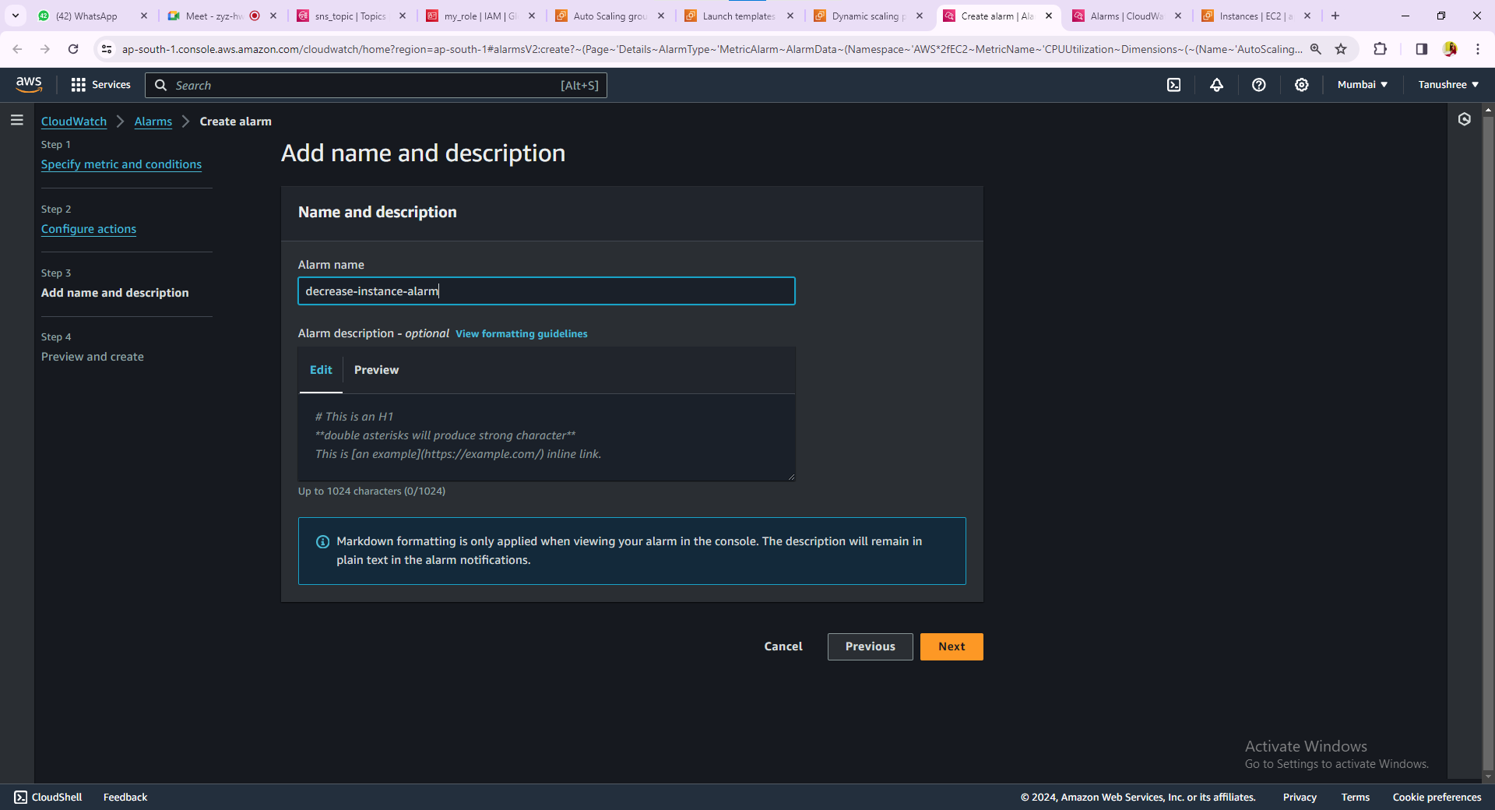14.The Intance Policy has been decreased.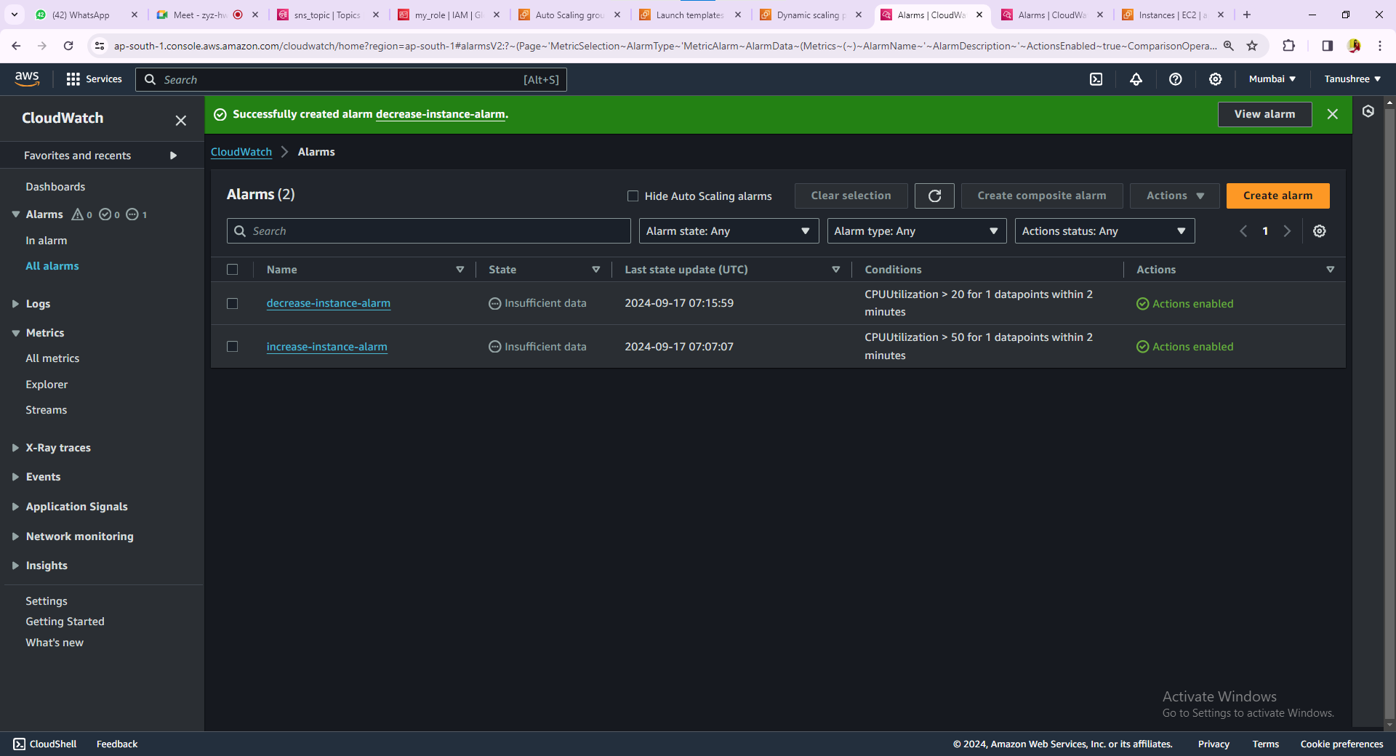

15.Now we will get the Notification.